Taking Action on Time Off Requests in Success Factors Quick Reference Guide
Last Updated: 11/7/2023

This guide outlines the steps required to take action (approve or decline) on a Time Off request. Note: The Time Off request feature does not replace conversations and planning between employees and supervisors.

Contents
Notification 1
Accessing SuccessFactors 2
Reviewing and Taking Action on Requests 2
Viewing Additional Request Details Before Declining or Approving 3
Supervisor – Delegating Requests 4

Notification
When a Time Off Request is submitted, approvers receive an email notification requesting review and action.  Click the link in the notificaiton to be taken directly to the request to be reviewed, or access SuccessFactors using the instrucitons in the next section of this document. | 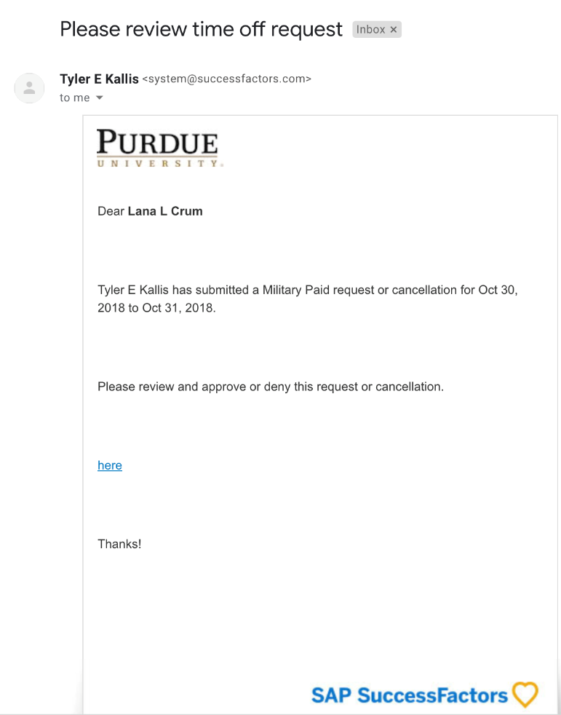

Accessing SuccessFactors
Access Employee Launchpad via OneCampus or other website connections. Log in with your User ID and Password. |  | https://one.purdue.edu/  

Note for Supervisors with Multiple Appointments
Supervisors with more than one appointment will have to switch to other account(s) to view pending actions that fall under those appointments by clicking the Change Selected Employment icon on the Navigation bar. | 

Reviewing and Taking Action on Requests
After logging in to SuccessFactors, navigate to Approvals and either approve (green check mark) from the tile or click the tile to review more details.  Click (v) to select Approve with Comments if wanting to add a note.  Tip: If you have many requests to process, click View All to see the individual requests.  You can also use the My Workflow Requests icon  ()to view the list format. This would allow you to Select All and quickly approve, decline or delegate. | 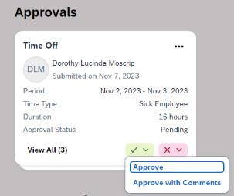  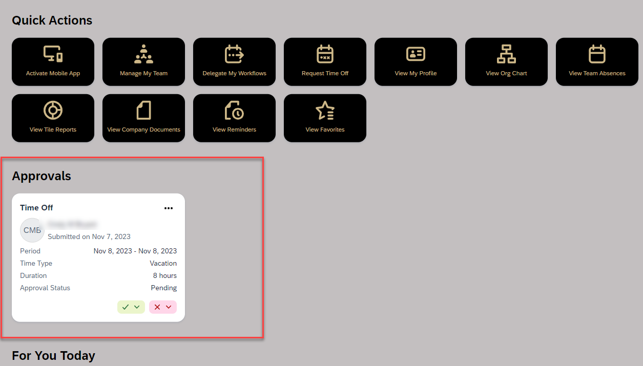  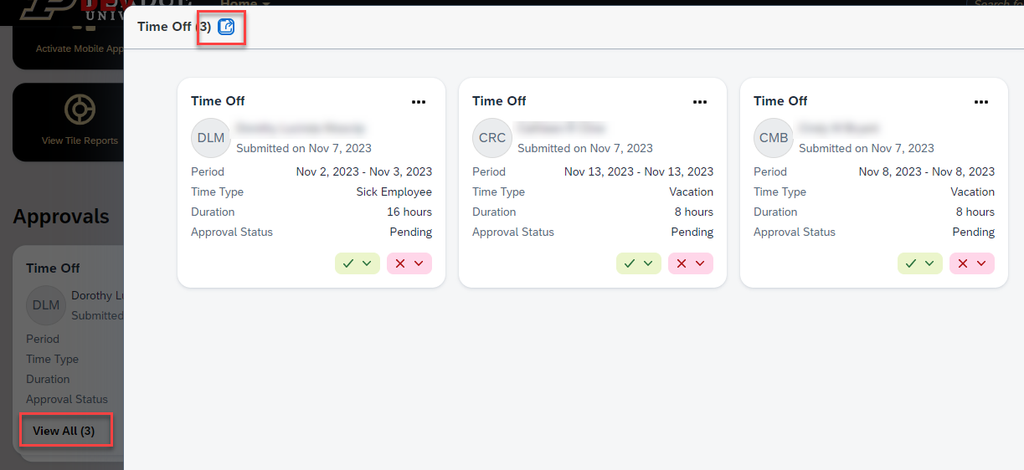  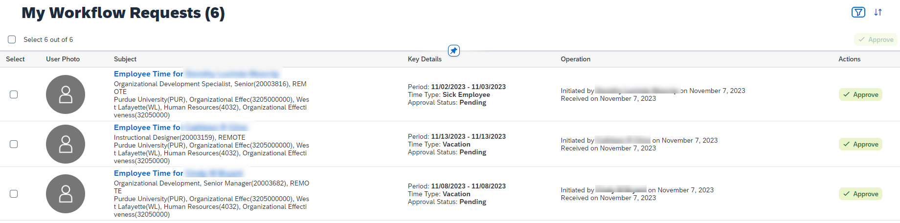

Viewing Additional Request Details Before Declining or Approving
As stated above, simply click on the original request to open the Workflow Details.  - The Comment feature can be used to send a note back to the employee. You must click Post to send the comment. A comment can be posted without Approving or Declining.  - To access Team Absence Calendar, click the link to view. If there are no other absences during that period – it simply states that.  - When ready to take action, click Approve or Decline. The employee will be notified in SuccessFactors and via email.  - You can also Delegate this to another individual. Once delegated, the request is no longer included in your Approvals. | 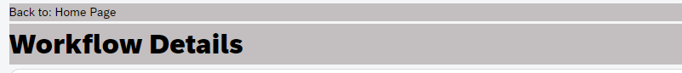  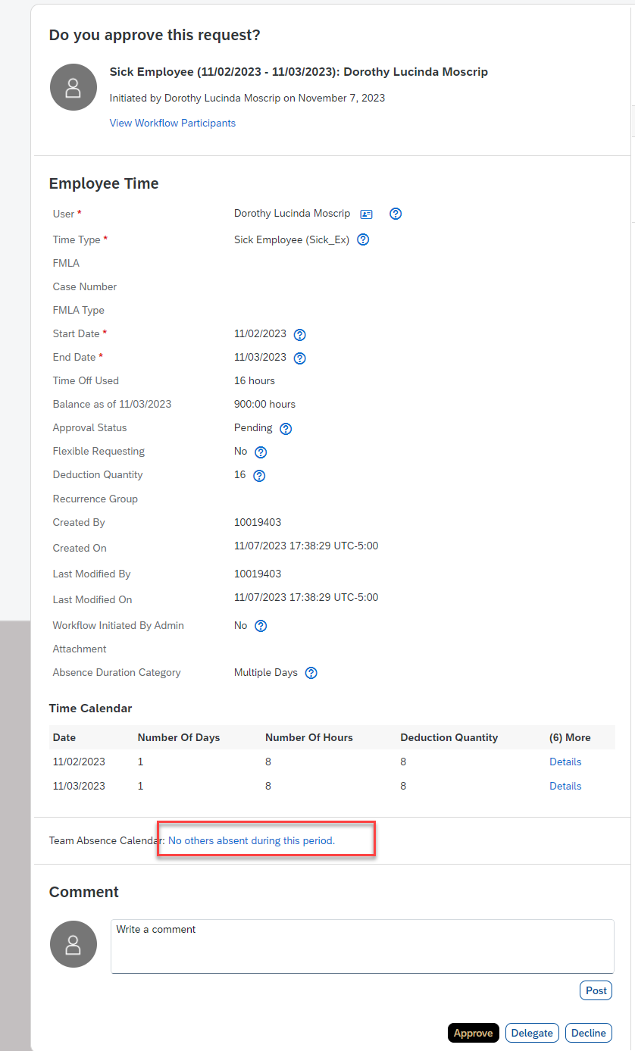

Supervisor – Delegating Requests
Click the original Request to open to Workflow Details, as stated above.  At the bottom of the details screen, click Delegate. | 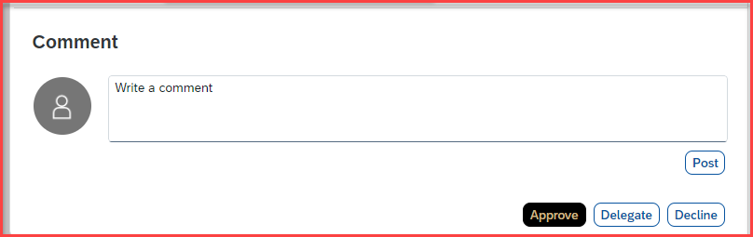
- Complete the field to indicate to whom you wish to delegate.  The field can be completed using the drop-down menu, or by typing a name to perform a search.  - Click Send.  - On the next screen, verify that you would like to Delegate. | 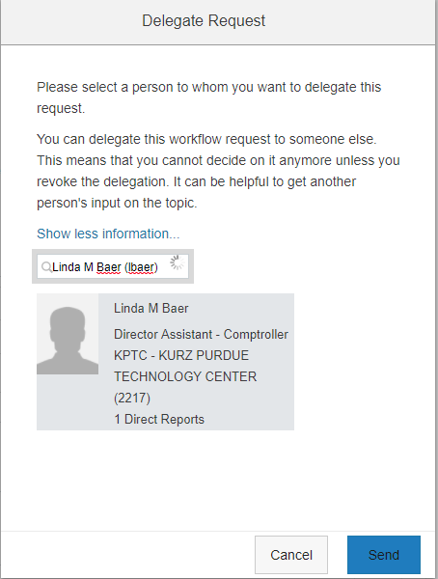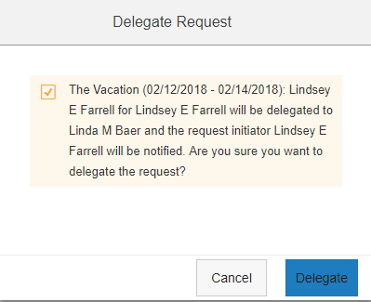  3  2  1
The supervisor to whom you delegated will see the request in their Approvals.  The Workflow Details indicates from whom it has been delegated.  The employee will be notified that the request has been delegated and to whom. | 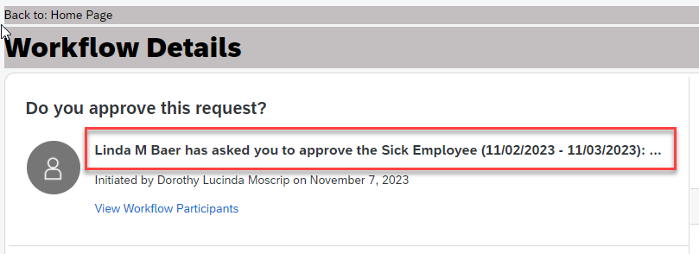
The delegated supervisor can Approve, Decline or Decline the Delegation to send back to original supervisor. | 